1. Use RHEL 9 ami in aws and launch ec2

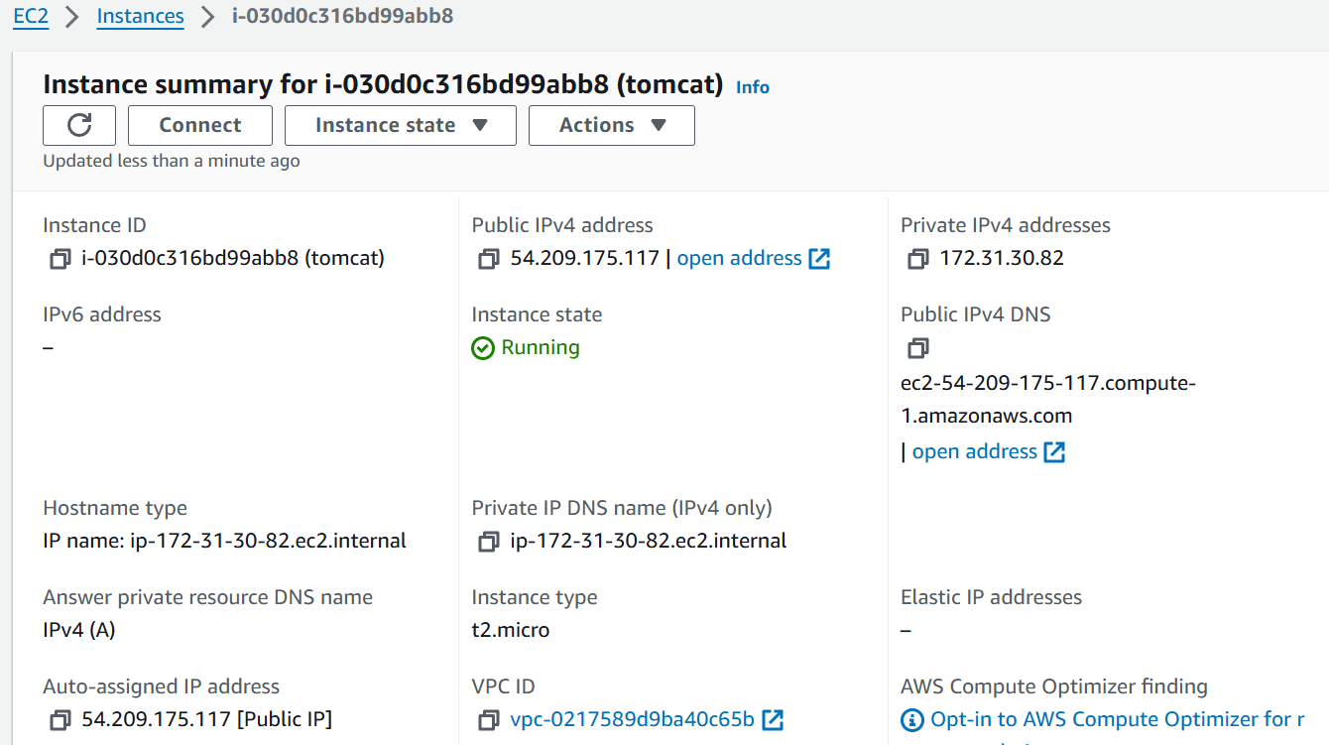

2) Install java-1.8 version only

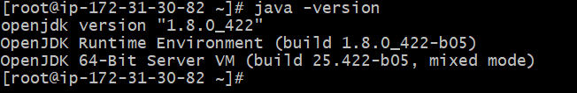

3)Setup tomcat-8.5 version only

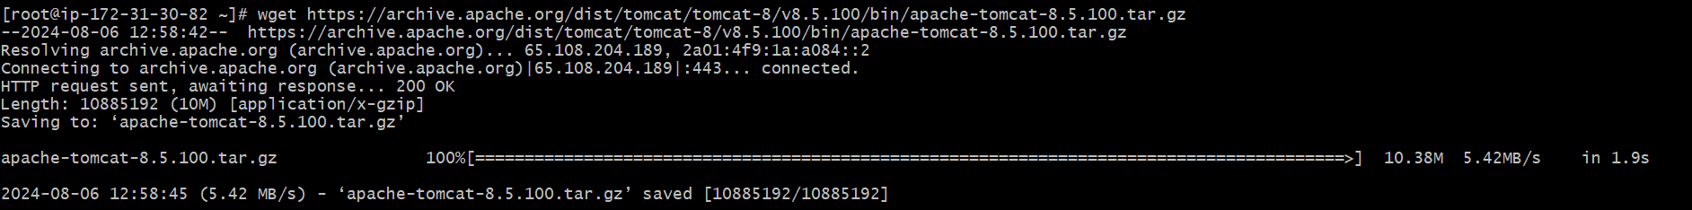

4)Deploy sample application in webapps



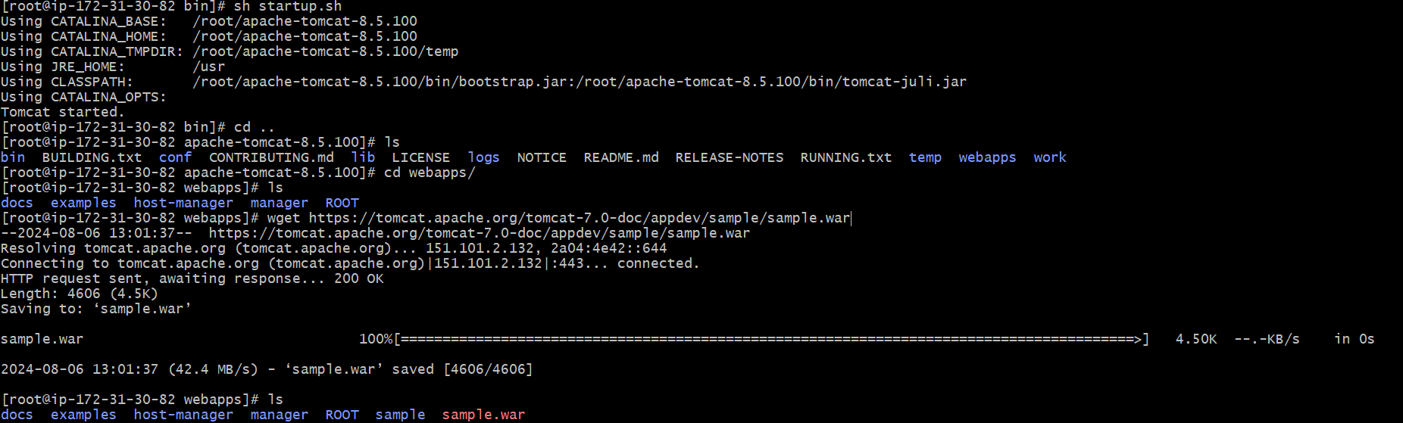

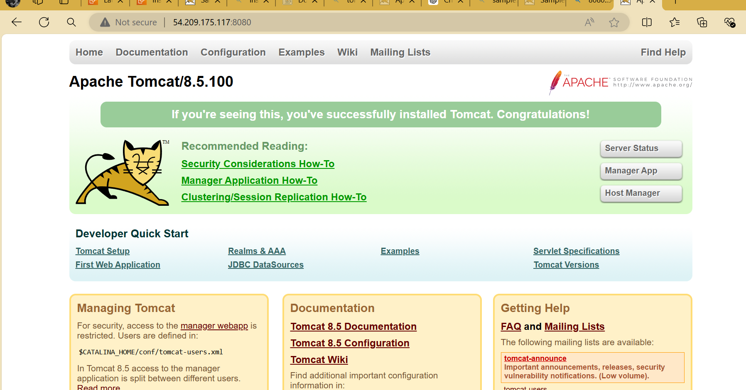

5) Access the application on browser.